**Danphe HIMS EMR EHR V.3.13.0 Release notes**

Danphe HIMS EMR EHR has bought many new features and changes with new version V.3.13.0 Given below the new changes are shown.

* **Highlights**

1. Central Admin Page for Hospital Info 2

2. Clear GST Details on Sales Invoices 2

3. New Pharmacy Settings Menu 2

4. Flexible Accounting Vouchers 3

5. Faster Dispensary Sales 4

6. New Cancel Voucher Option 4

7. Easy Medical Component Mapping 5

8. Free Text for Dosage in Medication Requests 6

9. Pharmacy Bill History Through Patient Module 6

10. New Global search Feature Added 7

* **Additional Features**

1. Referral Claim Code Handling 7

2. Purchase Margins Added 7

3. Improved Purchase Reports 7

4. Better External Lab Tracking 7

5. Referral Code Validation for ECHS 8

6. Vitals Based on Recent Records 8

7. OT Booking Charges in Billing 8

8. Improved Patient Search 8

9. Custom Visit Search Filters 8

10. Return Invoice Tagging 8

11. Updated Surgery Dropdowns 8

* **Highlights**

## Central Admin Page for Hospital Info

A new page has been added where administrators can easily update and manage hospital contact details, tax information, and logos — all in one place.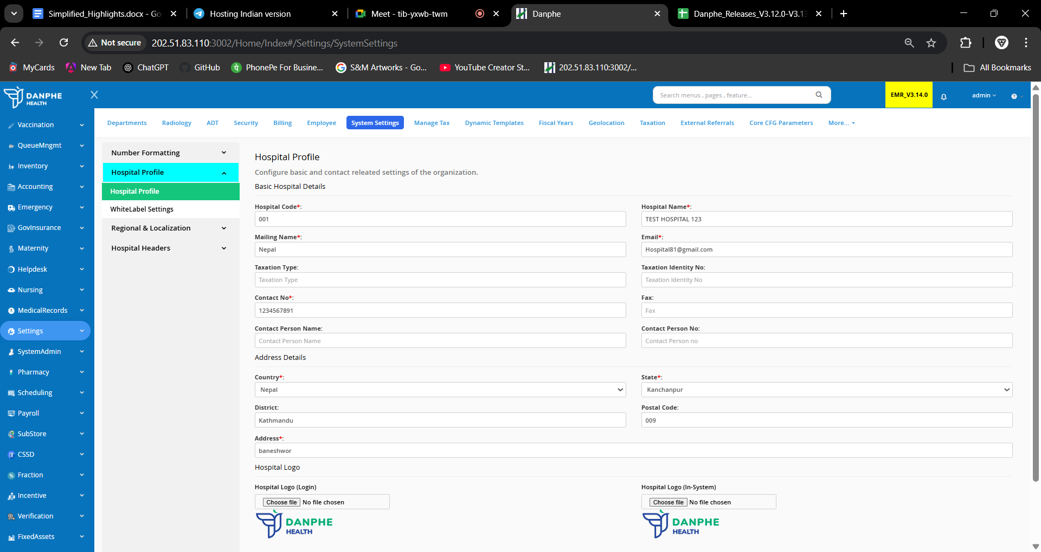

## Clear GST Details on Sales Invoices

Sales invoices now show a clear breakdown of GST (tax). The system automatically calculates the correct tax based on whether the transaction is within the same state (intrastate) or between states (interstate).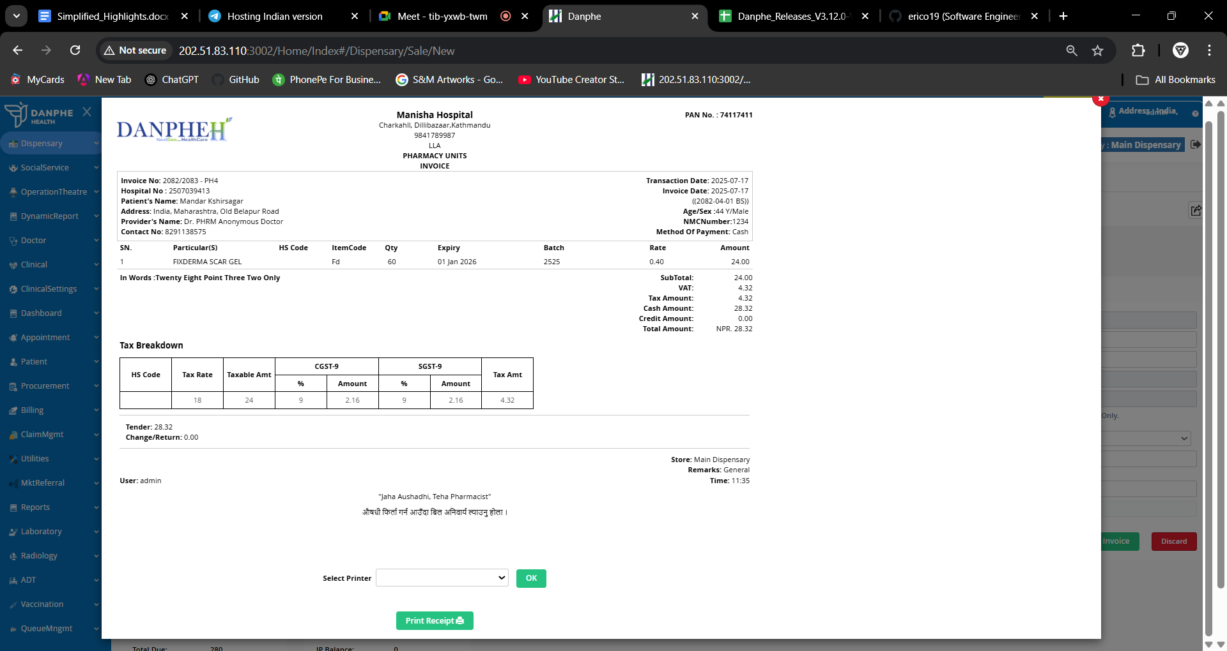

## New Pharmacy Settings Menu

Under the Pharmacy section, there’s a new Settings menu. Inside it, users can now access and manage:  
- Frequency (how often medicine is taken)  
- Routes (how the medicine is given – like oral, injection, etc.)  
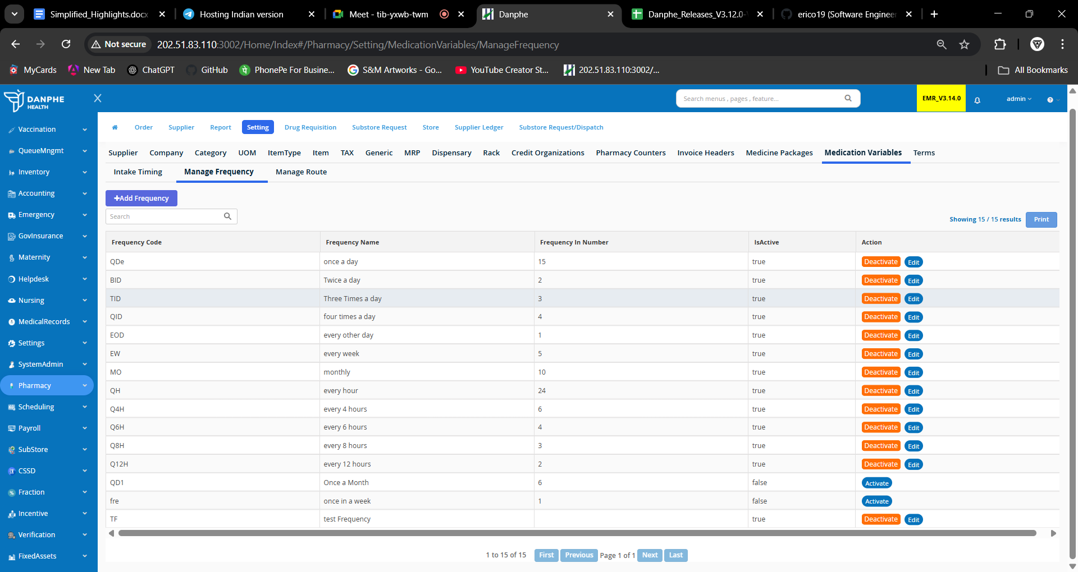

## Flexible Accounting Vouchers

Payment and receipt vouchers now support two formats:  
- Single entry

Only supports bank transactions via cheque

- Mixed entry

Can select between transaction mode either cash or bank (via cheque)  
This is controlled by a new setting called AccVouchersFormatConfig.

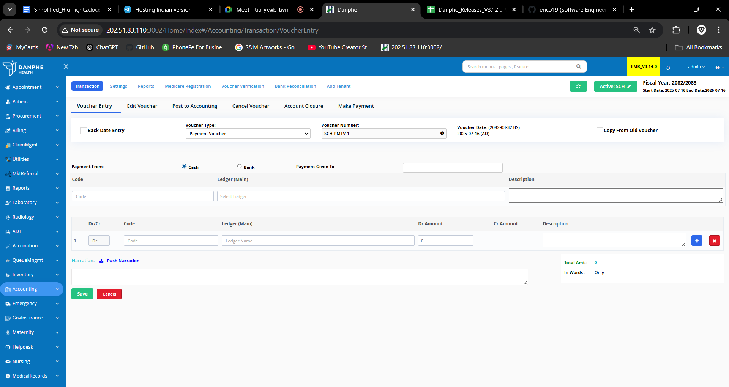

## Faster Dispensary Sales

The workflow is now simpler. Instead of two steps, updating the prescription quantity and completing the sale can now be done with just one button click.

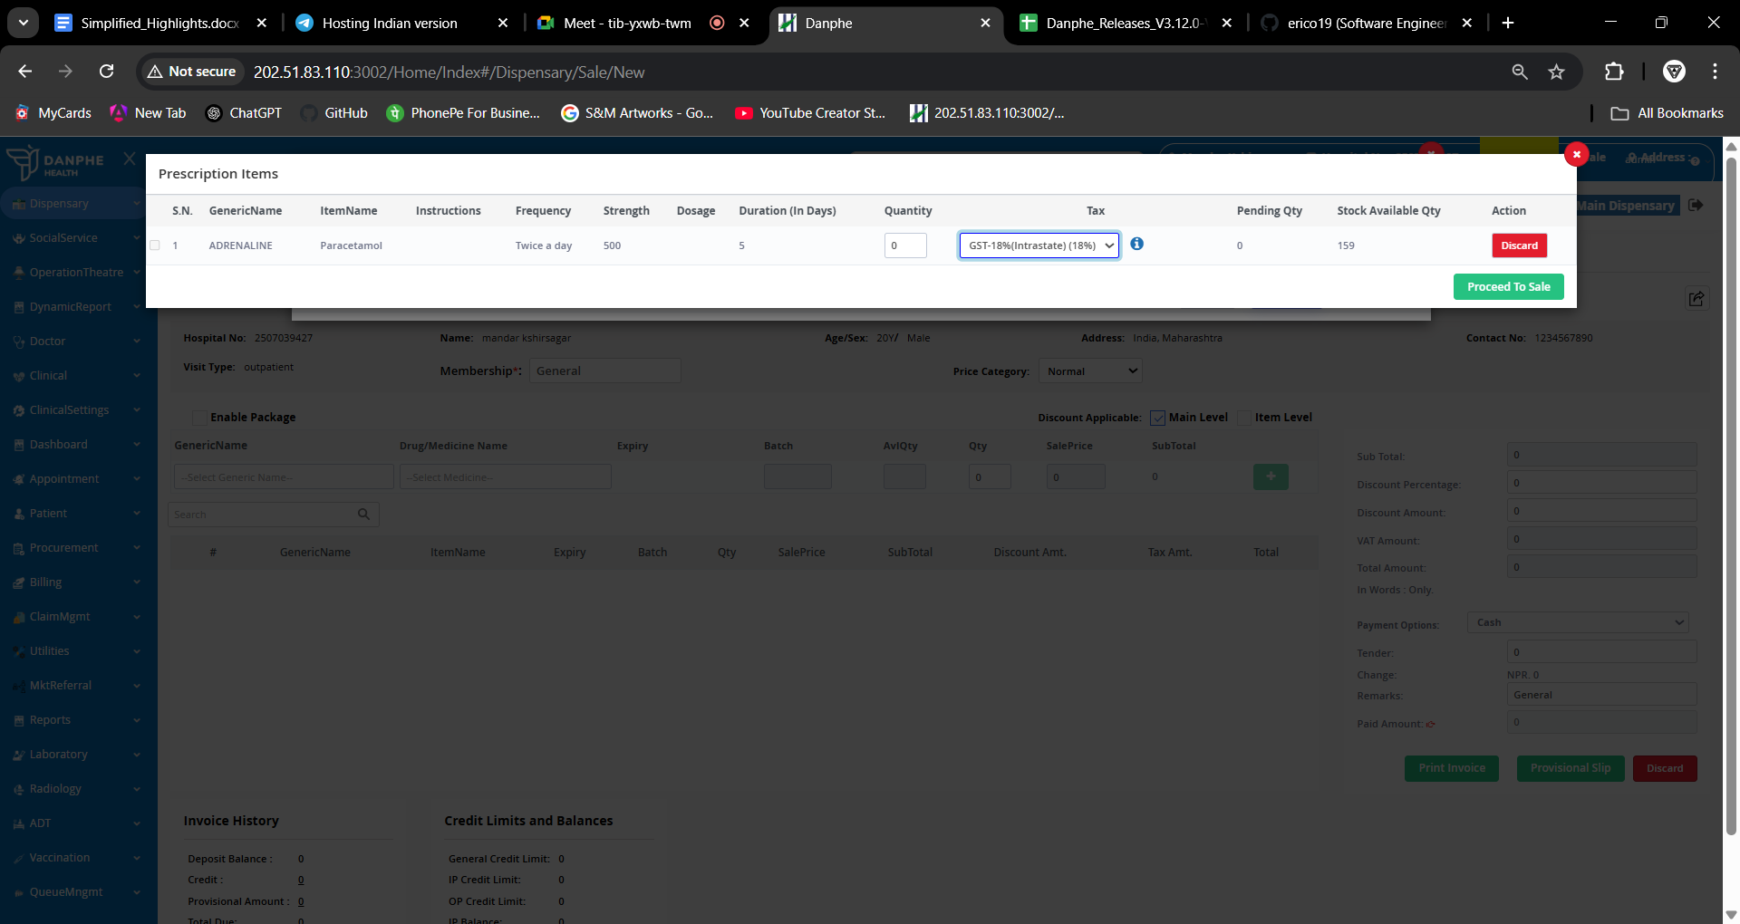

## New Cancel Voucher Option

A new Cancel Voucher tab has been added under Accounting to help manage and reverse incorrect or unwanted vouchers.

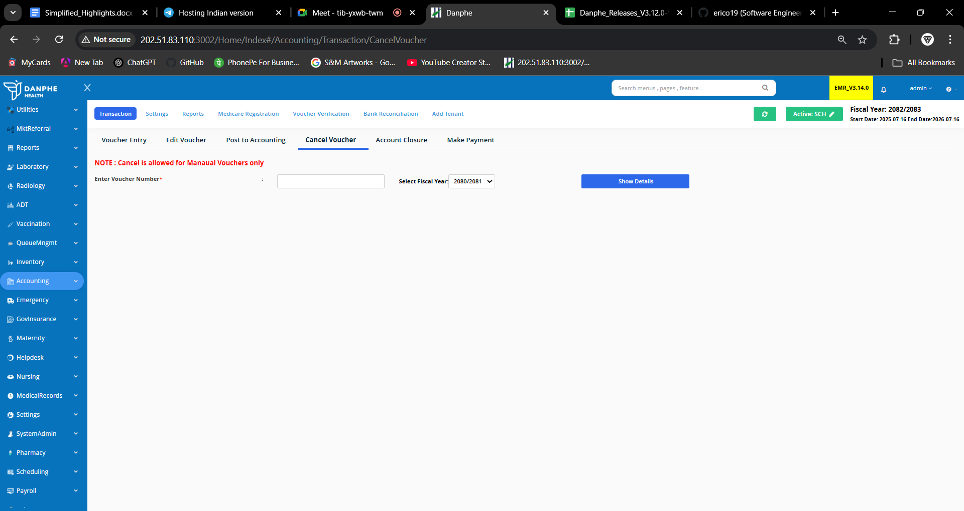

## Easy Medical Component Mapping

There is now a centralized place where users can link medical components (like services or equipment) to users or departments. This saves time and avoids having to navigate multiple screens.

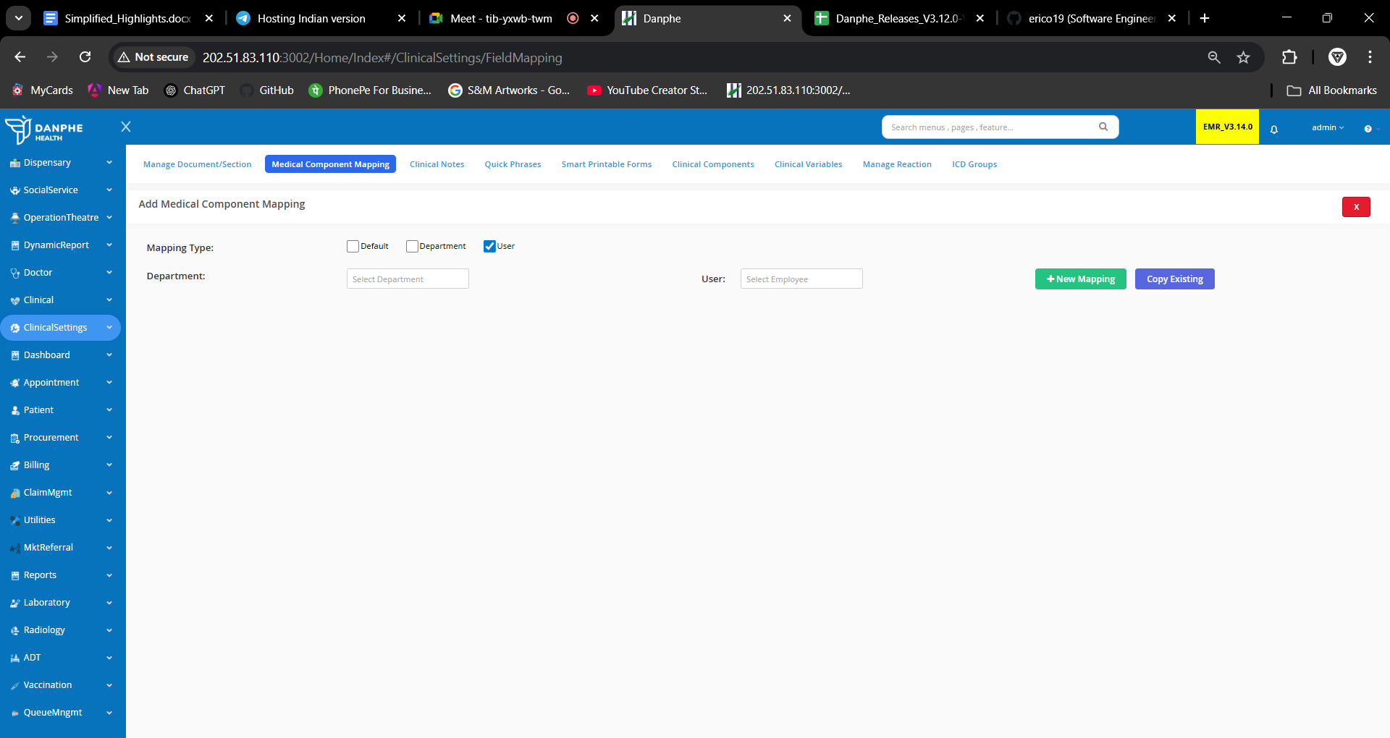

## Free Text for Dosage in Medication Requests

## On the Request Medication form, there's a new toggle button called 'Free Text Dosage'. This lets doctors or nurses enter their own dosage instructions freely, without choosing from predefined options.

# Pharmacy Bill History Through Patient Module

Users can now view detailed patient pharmacy billing history within the patient module.

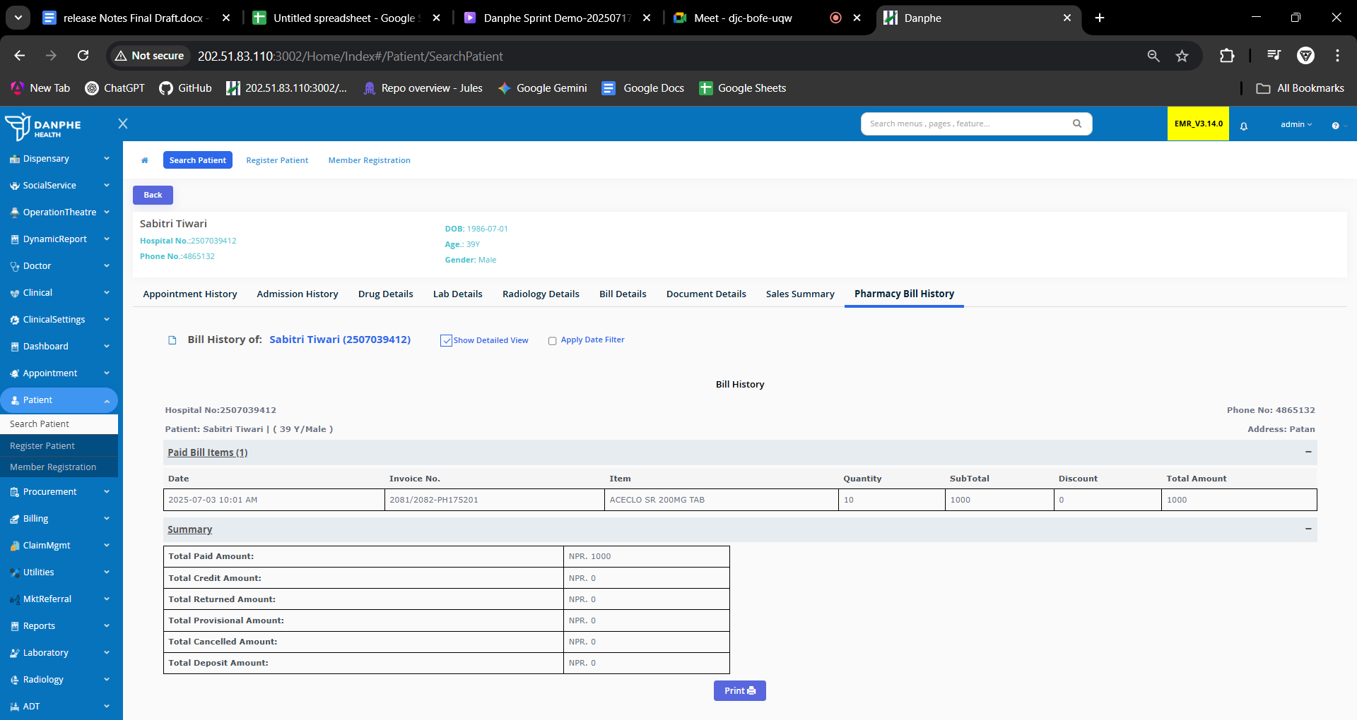

# New Global search Feature Added

A new Search tab has been integrated into the UI. This feature allows users to navigate to any sub-menu or page within the software by searching for its name.

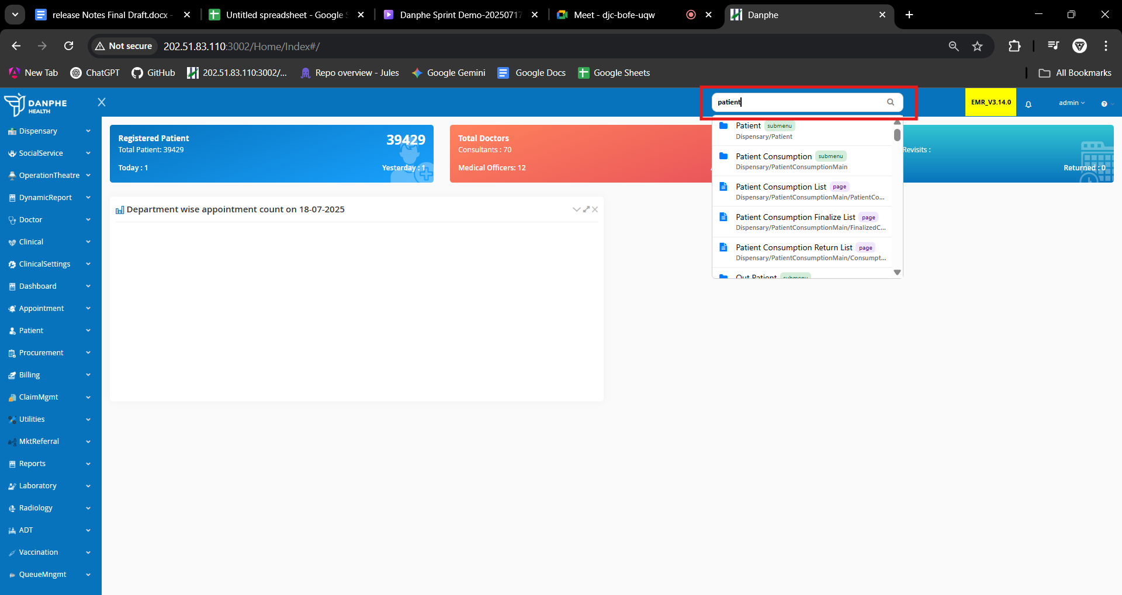

* **Additional Features**

## Referral Claim Code Handling

- If a patient is sent to another department on the same day, the system keeps the same claim code.  
- If the patient is moved to the Emergency Department, a new claim code is created automatically.

## Purchase Margins Added

You can now see profit margin details (both amount and percentage) for purchases. New columns added to show free quantities and total quantities.

## Improved Purchase Reports

The Item-wise Purchase Report now includes columns for:  
- Free Quantity  
- Total Quantity

## Better External Lab Tracking

New columns show dispatch and received dates of lab samples to improve tracking and status visibility.

## Referral Code Validation for ECHS

The system now checks referral codes every time a new visit is created for ECHS patients, ensuring rules are followed correctly.

## Vitals Based on Recent Records

Vitals are now shown based on the last few records (N records) instead of using date ranges.

## OT Booking Charges in Billing

OT (Operation Theatre) charges are now clearly shown in Inpatient Billing. All charges are added up and you can click to view details in a popup.

## Improved Patient Search

A new search filter has been added in several modules (like Dispensary, Billing, Appointments, etc.). You can turn this on using the setting: ConfigurePatientSearch.

## Custom Visit Search Filters

On the Manage Visits page, you can now filter by Policy No. or Member No. Labels and placeholder text can be customized for each hospital.

## Return Invoice Tagging

A new column called Return Status is added in the Invoice List. Invoices with returns now show a clear “R” icon for easy identification.

## Updated Surgery Dropdowns

The dropdowns for selecting surgery type and priority are now automatically filled with values from system settings, ensuring consistency.